**Minutes of Ceredigion Snooker League Annual General Meeting held at Aberaeron Hall on Thursday 5’th September 2024.**

**Present**: Adrian Williams (Secretary), Andrew James (Chairman), Dilwyn Smith (Vice Chairman & Fixture Secretary), Dai Morgan (Treasurer), Gerwyn Lloyd (Llanarth), Hywel Davies (Llanon), Andy Green (Rhydlewis), Stafford Morgan (Rhydlewis), Rhodri Morgan (Aberaeron), Eifion Harries (Aberaeron), Jon James (Aberaeron), Rhydian Owen (Llandysul), Gwynant Ellis (Penparcau), Lee Hayward (Llandysul), Bedwyr Davies (Llandysul) and Jon James (Aberaeron).

1. **Apologies**: Marc Rees (Felindre), Mike Newcombe (Rhydlewis), Daryl Walters (Aberaeron), and Gethin Davies (Rhydlewis).
2. **Minutes of last AGM**: The minutes were confirmed to be correct by Gwynant Ellis and seconded by Rhydian ap Owen.
3. **Matters Arising:**The Secretary stated that after speaking with Barry Brown that his accomplishments for playing for the men’s team was also added to the website. He also stated that sponsorship had been received from Nisa Ffosyffin, but ties had been severed with Absolute Snooker.  
   The 3 Miss Rule was also discussed to clarify a few points.
4. **Appointment of Officials:**   
   All league officials were reappointed into their posts on block.  
   Proposed by Andy Green and Seconded by Stafford Morgan.

**Appointed Officials 2024/25**:

Chairman: Andrew James  
Vice Chairman: Dilwyn Smith  
Secretary: Adrian Williams  
Treasurer: Dai Morgan  
Fixture Secretary Dilwyn Smith  
President Marc Rees

1. **League Formation**: Tables as at the end of last year   
     
   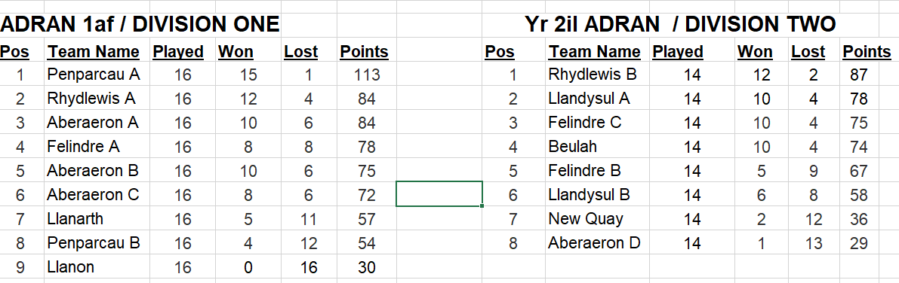  
     
   Four new teams have requested to enter the league –Aberaeron D, Llandysul D, Beulah B and Llanarth B.   
   No teams have withdrawn from the league.  
   The Aberaeron C team have transferred as Llandysul B.  
   Aberaeron D have renamed to Aberaeron C and Llandysul B have renamed to Llandysul C.  
     
   After some deliberation it was decided to promote the top two teams Llandysul A and Rhydlewis B from Division 2 and relegate Llanon from Division 1. This would give a split of 10 teams in Division 1 and 11 teams in Division2.  
     
   It was agreed that Penparcau A, Felindre C, Llandysul C, Llandysul D, Aberaeron C and Aberaeron D will play all their games on Wednesdays. Llanarth B will play their games on a Monday. Where problems arise with fixture dates then the captains are expected to resolve the issues amongst themselves.   
     
   The league formation was proposed by Rhodri Morgan and seconded by Lee Hayward.  
     
   It was agreed to start the league on Thursday 19’th September 2024.  
   The first half of the season will run from 19’th September to 19’th Dec and the second half from 9th Jan to 10’th April.
2. **Treasurers Report**: The Treasurer read out the statement of accounts   
   He stated that all teams were up to date with their payments and that the accounts were in a healthy state.  
   The Treasurer’s report was approved and agreed as correct by the committee.  
   Proposed by Stafford Morgan and seconded by Rhodri Morgan.
3. **Fees**:   
   **a) League Fees**: It was decided not to change the league fees for the 2024/25 season from £30 per team due to a healthy accounting year. This was proposed by Lee Hayward and Seconded by Dilwyn Smith.  
     
   **b) Secretaries Fees**: It was agreed not to change the fees from £200 for the 2024/25 season.  
   Proposed by Dai Morgan and Seconded by Andy Green.

**c) Web Developers Fees**: It was agreed not to change the fees from £50 for the 2024/25 season.  
Proposed by Adrian Williams and Seconded by Andrew James.

1. **Sponsorship and Raffle:**The Secretary stated that our current main sponsor ‘Nisa Ffosyffin’ will no longer be continuing as our main sponsor after 3 years. The Secretary will write a letter of thanks to Emyr Jones. JE Rees and Son are happy to sponsor for the next two years at £500 p.a. LHP Accountants may also be prepared to sponsor. The Secretary will contact them to scope out interest. World Snooker will also be approached. He stated that we are also still looking for a few other sponsors to cover some competition prize money, namely the two Doubles competitions.  
     
   It was agreed to do a raffle this coming season. Clubs will therefore be requested to provide raffle prizes for this year’s raffle. Once sufficient prizes have been received then the tickets will get printed to give plenty of time to sell prior to the Presentation evening draw.
2. **Presentation Evening:**  
   It was agreed to approach the Marine Hotel, Aberystwyth for prices and availability. It was agreed to hold the 2024/25 Presentation at the end of the season around April 2025.
3. **Proposals:  
   a) Playing handicaps in all matches (Llandysul)**Bedwyr raised the fact that most leagues that play the miss rule also use the player handicapping system. He felt that it may be a fairer system if handicapping was adopted. A lengthy discussion took place but it was decided not to carry out this proposal out but may be one for the future.  
     
   **b) Removing the Miss rule from all competitions (Llandysul).**  
   Bedwyr raised this issue that he felt the miss rule wasn’t really contributing too much to the league. A lengthy discussion took place noting that the game is slower and more negative since its introduction, but the majority were happy that it removed the aspect of ‘cheating’ by deliberately missing in order to have a safe cue ball. It was decided not to carry this proposal.  
     
   **c) Allowing all club members to participate in Individual competitions (Penparcau).**Gwynant raised the issue that many of their club players that were not team players would like to compete in the individual competitions. The Secretary read out the current rules that were previously amended to only allow team players to compete. After discussing the pros and cons it was decided that this proposal was carried. The Secretary will update the website to reflect this.

**d) Allowing Barry, Donald and Chris to play in any league event.**A discussion took place regarding the eligibility of these three players after they pulled out of the league previously causing a lot of problems reversing fixtures etc. It was unanimously carried that they would have to write a letter of apology to the league before they would be considered to play again. The league committee would have to decide on the sincerity of the letter before making a decision.  
  
**e) Refereeing protocol – Losing players refereeing next match**  
A discussion took place regarding the issue of players losing a match and leaving before refereeing the next match. Some members felt that there should be a punishment such as being banned from the next competition, but it was eventually agreed that this is an issue of etiquette. The expectation is that a losing player should always referee the next match but in the event that for a valid reason they cannot referee the match, then they should find someone else that can. The website will also get updated to reflect this.  
  
**f) Adding a page to the website for competition entry and fees**  
A discussion took place around this but the Secretary stated that this would be costly and not all that manageable. A page could be added to the website but to add a payment option would be very costly. This would also not be feasible as the payments would go to various clubs not just to one source. There is also an agreement in place from last January meeting that puts the onus on club captains to collate this info and fees and pass on to the Secretary.

**g) Individual competition format – round robin or knockout.**  
Andy Green raised the issue of having a definitive number to decide on the format of the individual competitions instead of having a majority decision. A lengthy discussion took place and it was decided that 6 players per table on a round robin was the maximum before a knockout would then take place. For a three-table venue this number would be 18 and for a two-table venue it would be 12. This was unanimously carried. The Secretary will update the website to reflect this

1. **Any Other Matters**:   
   **a) Workshop for exchanging information**.   
   Bedwyr gave a speech on how Llandysul have a very successful model in how to raise the profile of the club. This is achieved through advertising, recruitment and retention, easy access, competitions and a pleasant environment to play. He stated that they will be happy to put on a workshop day in October where other club members can come and have a more detailed breakdown on how they have achieved this and doubled their membership. The Secretary will assist in communicating with all the member clubs.  
   **b) Posters and Documentation**.  
   The Secretary stated that all relevant posters and documentation for the coming season will not be printed and posted out as done previously unless a club had no option to print them out from the website. The Secretary will message the club secretaries once this information is available to download and print.  
   **c) Scorecards.**  
   The Secretary stated that there is a large stock at Aberaeron snooker club that any team can take a batch away.  
   **d) Team 4 Wales**.  
   It was decided to have two teams. Ceredigion A and Ceredigion B with the A team consisting of the best available players.
2. **Date of Next AGM Meeting**: It was agreed to hold the next AGM on Thursday 4’th September 2025 at Aberaeron Memorial Hall.