Minutes of Ceredigion Snooker League Annual General Meeting held at Aberaeron Hall on Thursday 4’th September 2025.
Present: Adrian Williams (Secretary), Andrew James (Chairman), Dilwyn Smith (Vice Chairman & Fixture Secretary), Dai Morgan (Treasurer), Marc Rees (President), Gerwyn Lloyd (Llanarth), Gwilym Morgan (Llanon), Andy Green (Rhydlewis), Rhodri Morgan (Aberaeron), Eifion Harries (Aberaeron), Jon James (Aberaeron), Rhydian Owen (Llandysul), Gwynant Ellis (Penparcau), Brian Smith (Llandysul), Paul Adams (Llandysul), Bedwyr Davies (Llandysul), Tim Cox (Felindre), Iwan Williams (Felindre) and Chris Deakin (Llanarth).
- Apologies: Daryl Walters (Aberaeron), Gareth Davies (Penparcau ), Tony Wong (Penparcau ), Miles Freelan (Llandysul), Gethin Davies (Rhydlewis), Steve Griffiths (Llanon) and Aled Harries (Aberaeron).
- Minutes of last AGM: The minutes were confirmed to be correct by Gwynant Ellis and seconded by Gwilym Morgan.
- Matters Arising:
The Secretary stated that no response had been received back from LHP and World Snooker regarding sponsorship requests.
- Appointment of Officials:
All league officials were reappointed into their posts on block.
Proposed by Andy Green and Seconded by Bedwyr Davies.
Appointed Officials 2025/26:
Chairman: Andrew James
Vice Chairman: Dilwyn Smith
Secretary: Adrian Williams
Treasurer: Dai Morgan
Fixture Secretary Dilwyn Smith
President Marc Rees
- League Formation: Tables as at the end of last year
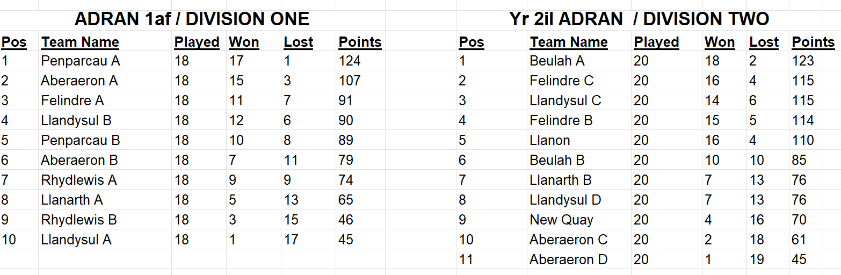
Four new teams have requested to enter the league – Penparcau C, Llanon B, New Quay B and Felindre D.
Three teams have withdrawn from the league – Rhydlewis A from Div 1 and Beulah B and Felindre C from Div2.
The Felindre D have renamed as Felindre B with Felindre B now being called Felindre C.
As the new Felindre team included Donald Newcombe, a letter of apology had to be accepted from the league committee. The chairman read out the letter for consideration. It was widely accepted that there was no apology made, but after a hotly contested debate it was agreed by a vote of 5 to 2 that he should be allowed to participate.
Another debate took place regarding which division this new team with four very strong players should play in. The league rules state that all teams should enter at the second division unless there are exceptional circumstances. After a close vote it was decided that this team should play in Division 2.
It was decided to promote the top two teams Beulah A and Felindre C from Division 2 and relegate Rhydlewis B from Division 1. This would give a split of 10 teams in Division 1 and 11 teams in Division2.
It was agreed that Penparcau A, Aberaeron A, Llandysul B, Felindre C, Llanarth B, Aberaeron D and Llandysul D will play all their games on Wednesdays. Where problems arise with fixture dates then the captains are expected to resolve the issues amongst themselves.
The league formation was proposed by Rhodri Morgan and seconded by Jon James.
It was agreed to start the league on Thursday 25’th September 2025.
The first half of the season will run from 25’th September to 18’th Dec and the second half from 8th Jan to 9’th April.
- Treasurers Report: The Treasurer read out the statement of accounts
He stated that all teams were up to date with their payments and that the accounts were in a healthy state.
The Treasurer’s report was approved and agreed as correct by the committee.
Proposed by Adrian Williams and seconded by Jon James.
- Fees:
a) League Fees: It was decided not to change the league fees for the 2025/26 season from £30 per team due to a healthy accounting year.
b) Secretaries Fees: It was agreed not to change the fees from £200 for the 2025/26 season.
c) Web Developers Fees: It was agreed not to change the fees from £50 for the 2025/26 season.
All fees were approved on block - Proposed by Rhodri Morgan and Seconded by Jon James.
- Sponsorship and Raffle:
The Secretary stated that we are still looking for 5 sponsors to cover the two Doubles, Under 40’s, Captains and the new Scotch Doubles competitions. A request was made to all members to actively try and secure some sponsorship deals.
It was agreed to do a raffle this coming season. Clubs will therefore be requested to provide raffle prizes for this year’s raffle. Once sufficient prizes have been received then the tickets will get printed to give plenty of time to sell prior to the Presentation evening draw.
- Presentation Evening:
It was agreed that members will approach venues in the mid and south of the county for prices and availability and report back for the January meeting.
- Proposals:
a) Penalties for cancelling League matches (Aberaeron & Felindre)
After the problems last season and also the season before where a few teams have failed to follow the current league rules resulting in matches not being played until well after their scheduled times, there is now a widespread acceptance that the rules need to be tightened to ensure this does not reoccur.
The Aberaeron Proposal was for the offending team to be docked 3 points which was refundable if played within two weeks.
The Felindre proposal was for no points deduction if played within two weeks but if unplayed then the non-offending team is awarded a 9-0 win.
After a lot of heated debate it was decided on a vote that the Felindre option was carried.
b) Penalties for cancelling Cup matches (Aberaeron & Felindre).
The proposal was that any cancelled cup matches would result in the offending team being eliminated, unless the non-offending team was prepared to play in the following two weeks. This again resulted in a heated debate. It was unanimously agreed in the end that the offending team is eliminated but with no option to a play at any later date.
c) Adopting the 3 Miss Rule for Division 2 and all Competitions (Felindre).
Again this stirred up a heated debate with the proposal eventually carried. It was agreed that the current rules needed a little tidying up with some points to be made more clearly.
Any Other Matters:
a) Workshop for exchanging information.
Bedwyr gave a speech on how Llandysul have a very successful model in how to raise the profile of the club. This is achieved through advertising, recruitment and retention, easy access, competitions and a pleasant environment to play. He stated that they will be happy to put on a workshop day in early November where other club members can come and have a more detailed breakdown on how they have achieved this and doubled their membership. It is expected that this will take the form of a 30 min presentation followed by a 30 min discussion. The Secretary will assist in communicating with all the member clubs.
b) Team 4 Wales.
It was decided to have two teams. Ceredigion A and Ceredigion B with the A team consisting of the best available players.
c) A discussion took place regarding the involvement of the league committee stepping in where 2 stubborn clubs can’t arrange a match. With the introduction of a new Captains Watts App group many clubs will see the efforts being made by individual teams any this should hopefully eliminate such issues. This group will also be used to report cancellations and for the non-offending captain to add three dates for replaying fixtures. This in turn will create a breadcrumb of evidence that can be used by the Executive Committee to decide on any decisions or punishments as deemed necessary.
Date of Next AGM Meeting: It was agreed to hold the next AGM on Thursday 3’rd September 2026 at Aberaeron Memorial Hall.

